Test your knowledge of UML design
Create a Class Diagram that you think best represents the situation below:
Railcars are either passenger cars or freight cars.
There are two types of Railcars, passenger cars and freight cars.
Passenger cars have 10 to 50 seats whilst freight cars have no seats but have one ramp and have a load capacity. There is only one type of ramp available, but the train company may choose other types of ramps in future.
The railcars may not always be attached to the train but there may be many cars of different type attached to a train. Trains can carry up to 12 railcars.
It is possible to book seats on a passenger car.
The seat booking is made in either a premium or economy class.
Passenger freight cars can have a combination seats.
Please do your best to identify the classes which are involved and then draw a UML diagram. Solution is provided on the next page but resist all attempt to view it before you’ve done your best!
Feel free to use any of the online tools for drawing a class diagram such as https://lucid.app or https://miro.com/app/dashboard/
However, there is no substitute for the timeless simplicity of using paper and paper to start off any design!

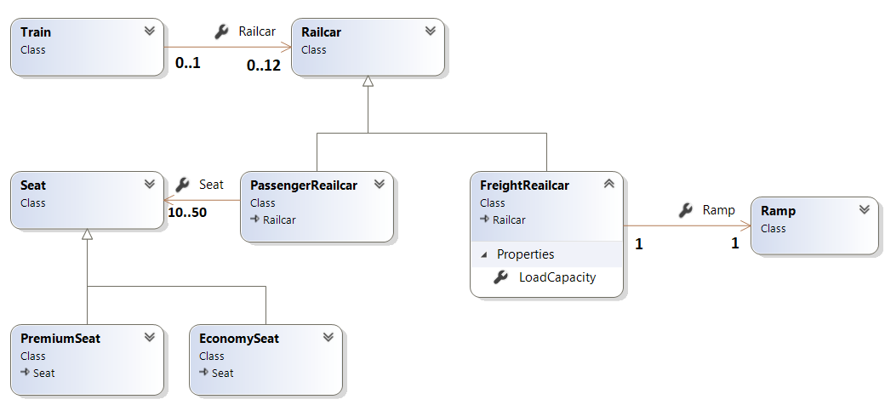

Here is a basic solution. Can you improve on this design?
Think about how a customer might books a seat.

